


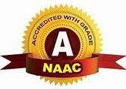
GOVBOT INDIA AI-POWERED GOVERNMENT WELFARE SCHEME ASSISTANT FOR EVERY INDIAN CITIZEN

21CS811-PROJECT PHASE II REPORT

Submitted By

KOODALARASU M | 714022104071
PRABIN C S | 714022104104
RAKSHAN VELUPILLAI P | 714022104115

in partial fulfilment for the award of the degree of

BACHELOR OF ENGINEERING IN
COMPUTER SCIENCE AND ENGINEERING

SRI SHAKTHI INSTITUTE OF ENGINEERING AND TECHNOLOGY

An Autonomous Institution, Accredited by NAAC with “A” Grade

ANNA UNIVERSITY: CHENNAI 600025

APRIL 2026

BONAFIDE CERTIFICATE

Certified that the project report “GOVBOT INDIA — AI-POWERED GOVERNMENT WELFARE SCHEME ASSISTANT FOR EVERY INDIAN CITIZEN” is the Bonafide work of KOODALARASU M (714022104071) , PRABIN C S (714022104104) and RAKSHAN VELUPILLAI P (714022104115) who carried out the work under my supervision.

SIGNATURE | SIGNATURE
Mrs.M.MANIMEGALA | Dr. K. E. KANNAMMAL
SUPERVISOR | HEAD OF DEPARTMENT
Assistant Professor | Professor and Head
Department of CSE | Department of CSE
Sri Shakthi Institute of  Engineering and Technology, Coimbatore – 641 062 | Sri Shakthi Institute of Engineering and Technology,  Coimbatore – 641 062

Submitted for the project work viva-voce Examination held on ..................

INTERNAL EXAMINER EXTERNAL EXAMINER

ACKNOWLEDGEMENT

First and foremost, I would like to thank God Almighty for giving me the strength. Without his blessings, this achievement would not have been possible.

We express our deepest gratitude to our Chairman Dr. S. Thangavelu for his continuous encouragement and support throughout our course of study.

We are thankful to our Secretary Mr. T. Deepan for his unwavering support during the entire course of this project work.

We are also thankful to our Joint Secretary Mr. T. Sheelan for his support during the entire course of this project work.

We are highly indebted to Principal Dr. N.K. Sakthivel for his Support during the tenure of the project.

We are deeply indebted to our Head of the Department, Computer Science and Engineering, Dr. K. E. Kannammal, for providing us with the necessary facilities.

It’s a great pleasure to thank our Project Guide Mrs. M. Manimegala for her valuable technical suggestions and continuous guidance throughout this project work.

We are also thankful to our Project Coordinator Ms. P. Sasikala for providing us with necessary facilities and encouragement.

We solemnly extend our thanks to all the teachers and non-teaching staff of our department, family and friends for their valuable support.

KOODALARASU M ( 714022104071 )
PRABIN C S ( 714022104104 )
RAKSHAN VELUPILLAI P ( 714022104115 )

ABSTRACT

GovBot India is an intelligent web-based platform designed to help Indian citizens discover, understand, and apply for government welfare schemes using Artificial Intelligence. The system provides a multilingual and culturally sensitive interface supporting farmers, students, senior citizens, women, and daily wage workers across India. A key feature of the platform is the Regional Avatar module, where users interact with AI assistants representing four regional zones of India, communicating in native languages including Tamil, Hindi, Malayalam, Kannada, Telugu, Bengali, and Gujarati.The platform includes a Document Vault where users can scan and securely store identity documents using AI-powered OCR with AES-256 encryption. An intelligent Eligibility Engine analyzes the user's profile and documents to identify central and state-level schemes they qualify for, then guides them step-by-step through the application process. The system also provides an Application Tracker, smart notifications for deadlines and installment alerts, and location-based state-specific scheme recommendations.The project demonstrates how artificial intelligence and modern web technologies can bridge the gap between Indian citizens and government welfare programs, ensuring that no eligible citizen is left behind.

TABLE OF CONTENTS

NO. | TITLE | PAGE NO.
 | ABSTRACT | 4
 | TABLE OF CONTENTS | 5
 | LIST OF FIGURES | 7
 | LIST OF TABLES | 8
 | LIST OF ABBREVIATIONS | 9
1 | INTRODUCTION | 11
 | 1.1 PROJECT PURPOSE | 12
 | 1.2 TARGET AUDIENCE | 12
 | 1.3 PROJECT OBJECTIVE | 12
 | 1.4 KEY FEATURES | 13
2 | LITERATURE REVIEW | 15
3 | SYSTEM SPECIFICATION | 24
 | 3.1 HARDWARE | 24
 | 3.2 SOFTWARE | 24
 | 3.3 BASIC ALGORITHM | 27
4 | METHODOLOGY | 30
 | 4.1 EXISTING SYSTEM | 30
 | 4.2 DRAWBACKS | 30
 | 4.3 PROPOSED SYSTEM | 31
 | 4.4 ADVANTAGES | 31
5 | IMPLEMENTATION OF PROPOSED METHODOLOGY | 33
 | 5.1 PROPOSED SYSTEM | 33
 | 5.2 DESIGN APPROACH | 34
 | 5.3 SECURITY AND PRIVACY | 35
 | 5.4 SYSTEM FUNCTIONALITY | 35
 | 5.5 FLOW DIAGRAM | 36
 | 5.6 GOVBOT INDIA PROCESSING ALGORITHM | 39
 | 5.7 IMPLEMENTATION OF PROPOSED METHODOLOGY | 40
6 | MODULE DESCRIPTION | 59
 | 6.1 AUTHENTICATION MODULE | 59
 | 6.2 CITIZEN PROFILE & DATA INPUT MODULE | 59
 | 6.3 SCHEME ELIGIBILITY ANALYSIS MODULE | 60
 | 6.4 DOCUMENT INTELLIGENCE MODULE | 60
 | 6.5 SCHEME INSIGHTS & ANALYTICS MODULE | 61
 | 6.6 REGIONAL AVATAR CHATBOT MODULE | 61
 | 6.7 REVIEW & FEEDBACK MODULE | 61
 | 6.8 PROFILE MANAGEMENT MODULE | 62
 | 6.9 SECURITY MODULE | 62
 | 6.10 USER INTERFACE (UI) MODULE | 62
 | 6.11 MODULE WORKFLOW DIAGRAM | 63
7 | RESULT AND DISCUSSION | 64
 | 7.1 RESULT | 64
 | 7.2 DISCUSSION | 65
8 | CONCLUSION AND FUTURE WORK | 66
 | 8.1 CONCLUSION | 66
 | 8.2 FUTURE WORK | 67
 | SOURCE CODE | 68
 | REFERENCES | 72

LIST OF FIGURES

FIGURE NO. | TITLE | PAGE NO.
5.1 | USER FLOW | 36
5.2 | SIGN UP PAGE | 41
5.3 | LOGIN PAGE | 42
5.4 | STATE SELECTION PAGE | 43
5.5 | REGIONAL AVATAR CHATBOT PAGE | 44
5.6 | CHANGE REGION PAGE | 45
5.7 | CHATBOT RESPONSE (WELFARE SCHEMES) | 46
5.8 | SCHEME CARDS DISPLAY PAGE | 47
5.9 | ELIGIBLE SCHEMES PAGE | 48
5.10 | NOTIFICATIONS PANEL | 49
5.11 | DOCUMENT VAULT PAGE | 50
5.12 | APPLICATION TRACKER PAGE | 51
5.13 | MY DASHBOARD OVERVIEW | 52
5.14 | MY PROFILE PAGE | 53
5.15 | APPEARANCE SETTINGS PAGE | 54
5.16 | EDIT PROFILE – OCCUPATION | 55
5.17 | EDIT PROFILE – INCOME & CASTE | 56
6.1 | MODULE WORKFLOW | 63

LIST OF TABLES

TABLE  NO. | TITLE | PAGE NO.
7.1 | DISCUSSION TABLE | 65

LIST OF ABBREVIATIONS

LIST OF ABBREVIATIONS

AI Artificial Intelligence

API Application Programming Interface

AES Advanced Encryption Standard

CNN Convolutional Neural Network

CSS Cascading Style Sheets

DB Database

HTML HyperText Markup Language

HTTP HyperText Transfer Protocol

IDE Integrated Development Environment

JS JavaScript

JSON JavaScript Object Notation

ML Machine Learning

NLP Natural Language Processing

OCR Optical Character Recognition

REST Representational State Transfer

UI User Interface

UX User Experience

VS Code Visual Studio Code

CRUD Create, Read, Update, Delete

JWT JSON Web Token

SPA Single Page Application

PWA Progressive Web Application

TTS Text-to-Speech

GIS Geographic Information System

IoT Internet of Things

GWDS Government Welfare Discovery Score

ECI Eligibility Confidence Index

REF Regional Eligibility Factor

DDC Document Detection Confidence

SRA Scheme Relevance Analysis

CHAPTER–1 INTRODUCTION

"Where Technology Meets Governance – empowering every Indian citizen through AI-driven welfare assistance."GovBot India presents a modern vision of intelligent governance by transforming the complex and often confusing government welfare ecosystem into a simple, accessible, and AI-powered assistance platform. In an era where millions of eligible Indian citizens miss out on welfare schemes due to lack of awareness, language barriers, and complicated application processes, the platform acts as a digital government officer that helps citizens discover, understand, and apply for schemes with confidence and clarity. By integrating multilingual AI, real-time eligibility analysis, and culturally sensitive regional avatars, GovBot India enables smarter welfare access through technology. GovBot India is not just an information tool, it is an intelligent support system designed to assist citizens throughout the entire scheme application lifecycle. From identifying eligible schemes and scanning identity documents to tracking applications and receiving smart notifications, the platform promotes efficient and inclusive access to government benefits. Features such as AI-driven eligibility detection, document vault with OCR, regional language support, and guided application flows contribute to improved awareness and informed decision-making among rural and low-income communities.

1.1 PROJECT PURPOSE

The purpose of "GovBot India AI-Powered Government Welfare Scheme Assistant for Every Indian Citizen" is to support Indian citizens in discovering, understanding, and applying for government welfare schemes using artificial intelligence and real-time eligibility analysis. The platform provides a unified system that assists users in scheme discovery, document management, eligibility verification, and guided application processing.GovBot India helps citizens identify schemes they qualify for, communicate in their native regional language, securely manage identity documents, and track their application status with ease. By combining AI models with multilingual support and location-based regional intelligence, the system improves welfare accessibility while reducing confusion, language barriers, and missed entitlements.

1.2 TARGET AUDIENCE

- Farmers and daily wage workers
- Students and educational scholarship seekers
- Senior citizens and pension beneficiaries
- Women and self-help group members
- Rural and low-income community members

1.3 PROJECT OBJECTIVE

The objectives of GovBot India focus on improving welfare accessibility and informed decision-making through intelligent digital solutions.

- To provide an AI-driven scheme discovery system:
Helping citizens identify eligible government welfare schemes based on location, profile, and documents.
- To enable multilingual regional assistance:
Allowing users to interact with regional AI avatars in their native language through the Regional Avatar module.
- To perform eligibility analysis and scheme matching:
Using profile data and AI models to identify suitable central and state-level welfare schemes.
- To support document management and security:
Scanning, extracting, and storing identity documents with AES-256 encryption and OCR technology.
- To detect eligibility using document analysis:
Providing accurate scheme qualification results based on uploaded Aadhaar, PAN, and passbook data.
- To improve application awareness:
Displaying guided application steps with smart notifications such as deadline alerts and installment reminders.

1.4 KEY FEATURES:

GovBot India integrates intelligent welfare assistance features focused on accessibility, eligibility, and guided application support.
- User-Friendly Interface: Simple and interactive dashboard designed for rural users, senior citizens, and first-time applicants.
- Secure Authentication: based login and secure user data management with session timeout protection.

- Regional Avatar Module: Interact with AI assistants Kavitha, Gurpreet, Priya, and Arjun in your native regional language.
- Document Vault: Scan, extract, and securely store Aadhaar, PAN, and bank passbook data using OCR and AES-256 encryption.
- AI-Based Eligibility Engine: Scheme suitability detection, profile matching, and eligibility verification using real-time document location data.
- Guided Application Flow: Step-by-step application assistance with document checklists and direct links to official government portals.
- Application Tracker: Monitor submission status of all applied welfare schemes in one place.
- Smart Notifications: Deadline alerts, installment reminders, and scheme announcement notifications.
- Scheme Recommendation Engine: AI-based system that provides personalized scheme suggestions based on occupation, income, location, age, and uploaded documents for accurate welfare matching.
- Citizen Welfare Score (Eligibility Index): An intelligent scoring feature that combines profile data, document verification, and location factors to generate a Welfare Eligibility Score (0–100), helping citizens quickly understand their overall scheme qualification status.
- Multilingual Support: Communicate and receive scheme information in Tamil, Hindi, Malayalam, Kannada, Telugu, Bengali, and Gujarati.
- State-Specific Scheme Intelligence: Automatically prioritizes and displays region-relevant schemes such as Kalaignar Magalir Urimai in Tamil Nadu and Rythu Bandhu in Telangana.
By embracing digital innovation, GovBot India aims to empower every Indian citizen with intelligent tools to discover welfare schemes, verify eligibility, manage documents, and complete applications efficiently and confidently.

CHAPTER–2 LITERATURE REVIEW
2.1 Government Welfare Scheme Accessibility in India (Zhang et al., 2016):
Zhang et al. introduced the concept of data-driven public welfare delivery, emphasizing the use of digital platforms, citizen profiling, and geographic information systems (GIS) to improve government scheme accessibility. Their study demonstrated how citizen data such as income levels, occupation, and location can significantly influence scheme eligibility outcomes. The research highlighted that traditional welfare access based on manual processes often leads to inefficient distribution, whereas data-driven systems improve inclusion and transparency.The authors also discussed the importance of integrating decision-support tools capable of processing multiple citizen variables simultaneously. Digital welfare platforms were shown to reduce exclusion errors, processing delays, and administrative inefficiencies.
Relevance to GovBot India: Provides the foundational idea of data-driven scheme matching used in GovBot India's location-based eligibility engine and profile analysis modules. [1]

2.2 Digital Inclusion Using AI Technologies (Wolfert et al., 2017):
Wolfert et al. explored digital inclusion ecosystems enabled by AI platforms that collect real-time citizen data from profiles monitoring income conditions, regional factors, and document verification. The study explained how continuous eligibility monitoring improves early decision-making and welfare distribution.
The research emphasized integrating cloud platforms for data storage and analytics, enabling citizens to access scheme insights remotely. Challenges such as language barriers, digital literacy, and affordability were also discussed.

Relevance: GovBot India adopts similar digital inclusion concepts by integrating multilingual support and real-time eligibility alerts without requiring technical expertise. [2]

2.3 Machine Learning Applications in Public Welfare (Kamilaris & Prenafeta-Boldú, 2018):
This study reviewed machine learning applications in public service delivery, including scheme prediction, eligibility classification, and benefit estimation. Algorithms such as decision trees, support vector machines, and neural networks were evaluated for citizen datasets.The authors concluded that machine learning significantly improves eligibility accuracy when regional and demographic variables are included. However, usability remained a major barrier for citizens unfamiliar with complex systems.
Relevance: GovBot India simplifies machine-learning outputs into citizen-friendly dashboards and AI-based scheme recommendations. [3]

2.4 Deep Learning for Document Verification (Mohanty et al., 2018):
Mohanty et al. demonstrated how convolutional neural networks (CNNs) can identify and extract information from identity documents with high accuracy. Their work used large document image datasets to classify and process data automatically.The research highlighted the importance of early document verification to prevent eligibility errors and improve application quality. Mobile and web-based implementations were proposed for real-world adoption.
Relevance: Directly supports GovBot India's OCR-based document vault module using visual analysis and extraction concepts. [4]

2.5 Climate and Regional Welfare Prediction Models (Jeong et al., 2019):
Jeong et al. proposed predictive welfare models incorporating regional variables such as state policies, income variability, and demographic deviations. Their findings showed strong correlations between regional conditions and scheme eligibility outcomes.The study emphasized adaptive models capable of generating dynamic eligibility predictions instead of static recommendations.
Relevance: GovBot India's location-aware eligibility prediction and regional scheme scoring are inspired by region-integrated prediction frameworks. [5]

2.6 Decision Support Systems for Public Services (Rao & Srivastava, 2019):
This research examined public service decision-support systems designed to assist citizens in scheme selection and application management. The study concluded that integrated platforms combining analytics, visualization, and advisory systems improve citizen confidence.Visualization tools were found to enhance understanding among non-technical users.
Relevance: Supports GovBot India's dashboard-driven design and graphical analytics like eligibility charts and scheme summaries. [6]

2.7 AI-Based Scheme Recommendation Systems (Sharma et al., 2020):
Sharma et al. developed AI models that recommend government schemes based on citizen income, occupation, location, and demographic patterns. The system improved welfare planning accuracy compared to manual selection methods.
The authors emphasized personalized recommendations tailored to specific geographic locations.
Relevance: Forms the theoretical basis for GovBot India's Scheme Eligibility and Recommendation module. [7]

2.8 Welfare Risk Prediction Using Demographic Analytics (Li et al., 2020):
Li et al. analyzed risk prediction models using demographic datasets to forecast exclusion errors, missed entitlements, and benefit gaps. Their model assigned eligibility risk levels based on citizen profile thresholds..
Relevance: GovBot India implements similar logic through profile-based eligibility risk assessment scoring. [8]

2.9 Web-Based Government Information Systems (Kumar & Patel, 2021):
This study focused on web platforms designed for government knowledge sharing and citizen service monitoring. The authors emphasized accessibility through browser-based systems rather than specialized software installations.
Cloud integration improved scalability and data persistence.
Relevance: Validates GovBot India's browser-accessible architecture using modern web technologies. [9]

2.10 Scheme Awareness and Visualization in Welfare Platforms (Singh et al., 2021):
Singh et al. investigated government welfare intelligence systems that analyze citizen eligibility datasets to assist users in making informed application decisions. The study emphasized that scheme complexity is one of the most critical barriers faced by citizens, often leading to missed benefits despite full eligibility. The researchers developed a framework that combines citizen profiles, regional policies, and document data to generate meaningful eligibility trends. The research highlighted the importance of visual analytics in welfare delivery, demonstrating that graphical representations such as eligibility charts, scheme timelines, and comparative dashboards significantly improve citizens' understanding of available benefits compared to raw text data. Monthly and category-based visualization models helped citizens identify applicable schemes and anticipate application deadlines.Additionally, the study discussed how integrating scheme data into citizen profiling systems allows users to align application decisions with expected welfare outcomes rather than relying solely on manual searches.
Relevance: GovBot India incorporates scheme awareness tracking along with visual eligibility analytics, enabling citizens to analyze applicable schemes and make better application decisions. [10]

2.11 AI Resource Optimization in Public Welfare Delivery (Fernandez et al., 2022):
Fernandez et al. proposed an AI-driven welfare resource optimization framework aimed at improving efficiency in document processing, eligibility verification, and application cost management. The research demonstrated how improper eligibility assessment leads to increased exclusion errors and administrative inefficiencies. Using predictive analytics, the system dynamically adjusted eligibility scores based on citizen profiles and regional policy conditions.
The authors emphasized profile-based prediction models that estimate total scheme eligibility before application decisions are finalized. Their experiments showed that intelligent eligibility allocation reduced processing time while maintaining citizen service quality. The study also explored accessibility aspects, highlighting reduced application complexity and minimized documentation errors. Another significant contribution was stage-based eligibility distribution, where scheme qualification was categorized into discovery, verification, application, and approval phases for clearer welfare planning.
Relevance: GovBot India adopts similar concepts through its Eligibility Engine module, which estimates scheme suitability, document requirements, and application steps while providing guided welfare navigation. [11]

2.12 Explainable AI in Public Service Platforms (Tjoa & Guan, 2022):
Tjoa and Guan explored the concept of Explainable Artificial Intelligence (XAI) and its importance in domains where users depend heavily on AI recommendations. The study argued that traditional AI models often function as "black boxes," making users hesitant to trust automated decisions. In welfare delivery, citizens require transparent explanations that clarify why certain schemes are recommended or rejected.The research proposed frameworks where AI outputs include interpretable components such as contributing factors, eligibility percentages, and recommendation reasoning. Experimental findings showed that systems providing explanations significantly increased user trust and adoption rates. The study also emphasized human-centered AI design, where outputs must be understandable even for users with limited technical knowledge. Visualization of eligibility factors and scheme explanations improved usability and confidence.
Relevance: GovBot India reflects explainable AI principles by displaying eligibility reasons, scheme criteria, regional influences, and recommendation insights instead of only numerical scores. [12]

2.13 Integrated Smart Welfare Platforms (Rahman et al., 2023):
Rahman et al. analyzed modern digital welfare platforms that integrate multiple government services into a single ecosystem. The research highlighted limitations of standalone welfare applications that address only one problem, such as scheme listing or document storage, without providing holistic citizen management.The authors proposed unified platforms combining eligibility monitoring, analytics, advisory services, and application tracking. Their findings indicated that citizens prefer centralized systems where all welfare-related information is accessible through a single interface. Integration reduces learning complexity and improves adoption among rural and low-income users. The study also emphasized real-time notifications and personalized dashboards as essential features for improving citizen engagement. Systems capable of tracking application lifecycle stages were found to significantly enhance welfare planning.
Relevance: GovBot India follows an integrated platform approach by combining scheme discovery, eligibility analysis, document management, application tracking, and regional intelligence within one unified system. [13]

2.14 AI-Driven Welfare Decision Support Systems (Chen et al., 2024):
Chen et al. studied intelligent welfare decision-support systems that use artificial intelligence and demographic data to assist citizens in scheme planning. The system combined regional information, citizen profiles, and document analysis to generate adaptive welfare recommendations. The study showed that AI-based decision tools help citizens improve application accuracy and reduce errors caused by complex eligibility conditions. The researchers emphasized the importance of eligibility evaluation alongside scheme discovery, allowing citizens to estimate qualification, documentation requirements, and benefit outcomes before application decisions are finalized.
Key advantages identified include:
- data-driven scheme planning
- real-time eligibility analysis
- automated application guidance
- personalized recommendations based on citizen profiles
Relevance: GovBot India applies these concepts through scheme suitability analysis, eligibility prediction, document verification, and guided application modules. [14]

2.15 AI-Based Welfare Eligibility Prediction and Early Alert Systems (Patel et al., 2024):
Patel et al. proposed an AI-based welfare eligibility prediction system designed to identify potential scheme qualifications using demographic conditions and document analysis techniques. The research combined regional parameters such as state policies, income thresholds, and occupation data with visual document monitoring to generate early eligibility alerts for citizens. The study demonstrated that early eligibility prediction significantly reduces missed entitlements and improves welfare access quality.
The authors emphasized the importance of accessible eligibility diagnosis tools that can assist citizens without requiring expert government knowledge. The system also provided application recommendations and preventive guidance based on detected eligibility risk levels.
Key contributions highlighted include:
- early eligibility prediction using demographic data
- document-based citizen profile analysis
- automated application recommendations
- reduction of missed benefits through preventive alerts
Relevance: GovBot India incorporates similar concepts through its document-based eligibility detection module and profile-aware scheme recommendation system. [15]

2.16 Web-Based AI Platforms for Inclusive Welfare Access (Garcia & Lopez, 2025):
Garcia and Lopez explored AI-powered welfare platforms developed using web technologies to improve accessibility and inclusion in government service delivery. Their research highlighted browser-based systems that allow citizens to access intelligent welfare tools without installing specialized applications.
Relevance: GovBot India follows this model by providing a browser-based AI platform integrating scheme discovery, eligibility analysis, and intelligent multilingual recommendations. [16]

2.17 Intelligent Welfare Analytics Platforms Using AI and Cloud Computing (Kumar & Verma, 2025):
The study highlighted that cloud-based AI platforms enable continuous eligibility monitoring, secure document storage, and personalized scheme recommendations for citizens across different regions. Results showed improved decision-making efficiency when analytics, visualization, and advisory services were combined within a single platform.
Major advantages identified were:
- cloud-based data storage and scalability
- real-time eligibility analytics and monitoring
- interactive dashboards for welfare insights
- personalized AI-driven scheme recommendations
Relevance: GovBot India follows this architecture by using a centralized backend with AI analytics, persistent eligibility summaries, and dashboard-based visualization for intelligent welfare decisions. [17]

CHAPTER-3

SYSTEM SPECIFICATION

3.1 HARDWARE
Processor: Intel Core i5 or higher, 3.40 GHz
RAM: 4 GB DDR4 or higher
Hard Disk: 500 GB HDD / 128 GB SSD
Network: Stable internet connection for real-time scheme data and eligibility API access
Display: Minimum 1366 × 768 resolution monitor
Operating System: Windows 10 or later / macOS / Linux
Input Devices: Standard 101/102-key keyboard and optical mouse
Mobile Support: Smartphone or tablet with modern web browser (optional)
3.2 SOFTWARE
FRONT-END:
HTML5:
HTML5 is used to structure the web application interface. It provides semantic elements that improve readability, accessibility, and SEO performance. HTML5 supports multimedia integration and works efficiently across all modern browsers without requiring additional plugins.
TAILWIND CSS:
Tailwind CSS is a utility-first CSS framework that enables rapid UI development using predefined utility classes. It helps maintain design consistency and reduces the need for writing custom CSS. Tailwind follows a mobile-first approach, ensuring responsive layouts across desktops, tablets, and mobile devices.
REACT JS:
React.js is a widely-used front-end JavaScript library that enables the development of fast, responsive, and interactive user interfaces. It follows a component-based architecture, which promotes code re-usability and efficient rendering. React improves user experience by updating only the parts of the UI that change, rather than reloading the entire page. It also integrates well with Tailwind CSS and supports responsive design through JSX-based structure and dynamic behavior.
JAVASCRIPT:
JavaScript is easy to learn because it is interpreted at runtime and does not require a lot of technology running behind the scenes. It is much easier to work with than other languages in its weight class, and it is easier to debug, test, and write than them too.
REACT ROUTER:
React Router is used for client-side navigation within the application. It allows seamless page transitions without reloading the entire webpage, improving application speed and user experience.
RECHARTS (DATA VISUALIZATION):
Recharts is a charting library used to visualize welfare data such as eligibility results, scheme statistics, and application analytics. It helps users understand analytical insights through interactive graphs and dashboards.
VITE (Frontend Build Tool):
Vite is a modern frontend build tool that provides fast development server startup and optimized production builds. It improves performance through efficient module bundling and hot module replacement.

BACK-END:
NODE.JS:
Node.js is a JavaScript runtime environment that enables server-side execution of JavaScript. It is used to handle API requests, manage application logic, and support scalable backend operations.
EXPRESS.JS:
A web framework built on top of Node.js that makes creating servers and APIs easier by providing simple tools for handling routes and requests.
REST API DEVELOPMENT:
REST APIs enable communication between frontend, backend, and AI services. They allow secure data exchange for eligibility predictions, document extraction results, and user authentication processes.
JWT AUTHENTICATION:
JSON Web Token (JWT) authentication is implemented to securely manage user sessions. It ensures authorized access to protected routes and maintains secure communication between client and server.
DATABASE MANAGEMENT:
• Firebase Firestore is a cloud-based NoSQL database used to manage and store the application's backend data. Unlike traditional relational databases, Firestore stores data in flexible JSON-like documents, which makes it easier to work with dynamic schemas such as user profiles, scheme lists, eligibility records, and application logs.
• For scalable data persistence of user documents, notifications, and application history. Firebase Authentication is used for secure multi-user login and session management across the platform.

ARTIFICIAL INTELLIGENCE / MACHINE LEARNING:
GROQ AI (Llama 3.3):
Groq AI with Llama 3.3 is used for implementing natural language processing and multilingual conversation features. It powers the regional avatar chat system and scheme recommendation engine with fast and accurate AI responses.
TESSERACT.JS (OCR ENGINE):
Tesseract.js is used to perform optical character recognition directly in the browser. It extracts text data from uploaded identity documents such as Aadhaar, PAN, and bank passbooks without sending sensitive data to external servers.
AZURE NEURAL TTS (TEXT-TO-SPEECH):
Azure Neural Text-to-Speech is used to convert scheme information and AI responses into spoken audio output. It supports multiple regional Indian languages enabling voice-based accessibility for rural and low-literacy users.
PREDICTIVE ANALYTICS MODELS:
Machine learning models analyze demographic and regional data to predict scheme eligibility, application success probability, and welfare benefit outcomes.
COMPUTER VISION:
OCR MODEL FOR DOCUMENT DATA EXTRACTION:
Optical Character Recognition models are used for image processing and data extraction from identity documents. The model analyzes uploaded document images and extracts key fields with high accuracy, enabling automated eligibility verification.
APIs & TOOLS:
Government Scheme API: Provides real-time scheme data used for eligibility matching and scheme discovery.
RESTful APIs: Enable structured communication between system modules.
Git & GitHub: Used for version control, collaboration, and project management.
3.3 BASIC ALGORITHM:
GOVBOT INDIA – Scheme Discovery, Eligibility Analysis & Guided Application Flow Algorithm:
The algorithm defines the logical workflow of the GovBot India system, which integrates frontend interaction, backend processing, AI-powered eligibility analysis, and OCR-based document extraction. The system collects citizen inputs from users, processes them using AI models, and provides intelligent scheme recommendations, eligibility results, and guided application support in real time.
Step 1: Start & Initialize System Components
- Load React UI components (Home, Chat, Eligibility, Tracker, etc.).
- Initialize frontend environment using Vite.
- Establish connection with Node.js and Express backend server.
- Initialize and run REST APIs for communication between frontend, backend, and AI service.
- Load application configurations and API keys (Groq AI, Azure TTS, Firebase).
Step 2: User Input Collection
Wait for user interaction through the interface:
- User enters personal details:
i. Location (State and District)
ii. Occupation and income level
iii. Age, gender, and family details
iv. Category (General / OBC / SC / ST)
- User uploads identity documents for OCR extraction.
- Validate user input fields before submission.
Step 3: Data Processing
- Send input data from React frontend to backend using REST API.
- Backend preprocesses data.
- Fetch real-time scheme information using Government Scheme API (if location is provided).
Step 4: AI Eligibility Analysis & Scheme Matching
- Generate eligibility results using classification and matching algorithms.
- Send eligibility results back to Node.js backend.
- Backend forwards processed data to Groq AI service.
Step 5: Document Data Extraction (OCR)
If document image is uploaded:
- Process document image using Tesseract.js in browser.
- OCR model analyzes image patterns and text fields.
- Extract key data such as name, Aadhaar number, and date of birth.
- Return extracted data, confidence score, and verification status.
Step 6: Response Generation & Visualization
- Backend sends eligibility and scheme results to frontend.
- Display results using dashboards and eligibility charts (Recharts).
Step 7: Data Storage & User History
- Store user profiles and eligibility results in Firebase Firestore.
- Maintain application history for future tracking and comparison.
- Secure data using JWT authentication and AES-256 encryption.
Step 8: End Process
- Display final scheme recommendations and eligibility insights to the user.
- Allow user to repeat eligibility check or upload new documents.

CHAPTER–4 METHODOLOGY

4.1 EXISTING SYSTEM

Traditional government welfare access mainly depends on citizen awareness, manual document submission, and local administrative knowledge. Citizens often rely on word-of-mouth information, past experiences with government offices, or advice from nearby sources rather than data-driven eligibility analysis. Most currently available welfare support systems suffer from limited automation and do not integrate scheme discovery, document verification, and eligibility analysis into a single platform. Scheme identification is typically done manually, which requires administrative knowledge and delays application decisions. Additionally, many government advisory tools are portal-dependent and require complex navigation, creating accessibility barriers for citizens using low-end devices, regional languages, or unstable networks.

4.2 DRAWBACKS

- Manual eligibility checking: Citizens depend on traditional awareness without AI-based scheme matching support.
- Lack of document intelligence: Existing systems do not automatically extract and verify identity documents using OCR.
- Fragmented solutions: Scheme information, eligibility checking, and application guidance are available on separate platforms.
- Low accuracy matching: No predictive analytics for welfare eligibility estimation before application submission.
- Poor visualization: Lack of analytics dashboards for understanding scheme eligibility and application status.
4.3 PROPOSED SYSTEM

The proposed system, GovBot India AI-Powered Government Welfare Scheme Assistant for Every Indian Citizen, is a web-based AI-powered welfare assistance platform designed to support Indian citizens throughout the scheme discovery and application lifecycle. The platform integrates natural language processing, optical character recognition, and real-time eligibility APIs to provide smart welfare guidance. Citizens can identify eligible schemes using predictive analytics that estimate qualification scores, document requirements, and benefit outcomes.GovBot India also includes an AI-powered regional avatar chatbot that provides instant welfare guidance, answers scheme-related queries, and suggests eligible programs based on citizen profile, location, and uploaded documents. The system supports multilingual interaction in Tamil, Hindi, Malayalam, Kannada, Telugu, Bengali, and Gujarati, ensuring accessibility for rural and low-literacy users. Additionally, tracking module, where users can monitor submission statuses, receive deadline notifications, and track benefit disbursement progress. The platform further displays state-specific scheme recommendations and visual eligibility analytics, enabling citizens to understand welfare entitlements and maximize benefit access.

4.4 ADVANTAGES
Smart Welfare Assistance:
- AI-based scheme discovery and eligibility prediction.
- Real-time regional avatar chatbot support for welfare queries.
- Early document verification using OCR and daily scheme notification tracking with visual analytics.
Technical and Functional Benefits:
- Machine Learning models for eligibility prediction and scheme matching.
- OCR-based document intelligence for identity verification.
- REST API integration for seamless communication.
- Secure authentication using JWT middleware and AES-256 encryption.
User Experience Improvements:
- Multilingual regional avatar chatbot for easy communication in native languages.
- Application tracking and smart notification system for scheme updates.
- Responsive UI built with React and Tailwind CSS.
- Data visualization using charts and dashboards.
Developer-Friendly and Scalable:
- Modular Node.js and Express.js backend architecture.
- Firebase Firestore database for scalable data storage.
- Easy expansion for additional AI modules.
Cost-Effective and Secure:
- Browser-based platform, no installation required.
- Uses open-source technologies to reduce cost.

CHAPTER–5
IMPLEMENTATION OF PROPOSED METHODOLOGY

5.1 PROPOSED SYSTEM
The proposed GovBot India system introduces an intelligent welfare assistance platform designed to support Indian citizens through real-time scheme guidance, eligibility analysis, and AI-based decision support. The system is developed as a web-based application that enables citizens to access government welfare insights without requiring advanced technical knowledge or specialized devices. Built using modern web technologies such as React for the frontend and Node.js backend with Groq AI integration, GovBot India processes user inputs through text, regional avatar chatbot interaction, or location-based eligibility services.At its core, GovBot India uses machine learning models and government scheme datasets to deliver scheme suggestions, eligibility alerts, and application-related insights. The regional avatar module allows citizens to ask welfare-related questions in natural language and receive instant responses in their native language. Additionally, GovBot India supports full multilingual interaction in Tamil, Hindi, Malayalam, Kannada, Telugu, Bengali, and Gujarati, ensuring accessibility for diverse citizen communities across all regions of India. The platform also includes an application tracking and notification system where users can monitor scheme statuses and receive deadline reminders, improving platform reliability and citizen engagement. By combining AI analytics, conversational regional assistance, and real-time government welfare information, GovBot India enhances decision-making and promotes inclusive welfare access for every Indian citizen.

5.2 DESIGN APPROACH:
The design of GovBot India focuses on simplicity, accessibility, and usability for Indian citizens and welfare seekers. The interface is structured to provide clear navigation and easy interaction even for first-time users. Key design principles include:
- Clarity: Clean dashboard displaying scheme recommendations, eligibility results, and welfare insights.
- User-Friendly Navigation: Quick access to regional avatar chatbot, eligibility checker, document vault, and application tracker.
- Responsive UI: Optimized layout for mobile devices, tablets, and desktops to support access from rural and low-connectivity areas.
- Smart Welfare Features: Provides scheme suitability analysis, eligibility prediction, document verification, application guidance, and notification support to help citizens make data-driven welfare decisions.
- Accessibility: Supports full multilingual interaction in Tamil, Hindi, Malayalam, Kannada, Telugu, Bengali, and Gujarati with simple user interactions to ensure ease of use for citizens with different technical backgrounds.
The UI incorporates readable typography, intuitive icons, and minimal interaction steps to ensure citizens can quickly obtain required scheme information. Performance optimization ensures fast loading and smooth interaction even in low-network conditions.

5.3 SECURITY AND PRIVACY

GovBot India ensures user data protection through secure authentication and encrypted communication using HTTPS protocols. User inputs, citizen profiles, and identity document data are handled securely and used only for welfare eligibility analysis and scheme recommendation purposes. Access control mechanisms prevent unauthorized system usage, while AES-256 encryption protects stored documents, user preferences, and application history records. The system follows ethical AI practices by limiting data collection to essential welfare assistance functionalities. Consent logging ensures citizens are fully aware of how their data is used before any document scanning or profile analysis is performed. Regular system monitoring and updates help maintain platform reliability, ensuring citizen trust and safe usage of AI-powered government welfare services.

5.4 SYSTEM FUNCTIONALITY

GovBot India provides intelligent welfare assistance by integrating scheme discovery, eligibility analysis, document verification, application guidance, and notification tracking within a single platform. The system uses location and demographic data to generate accurate scheme recommendations and eligibility insights. Citizens can monitor application progress, analyze scheme qualifications, and plan document requirements efficiently through an easy-to-use dashboard and regional avatar chatbot assistance. This integrated functionality helps improve welfare accessibility, reduce missed entitlements, and support better decision-making for every Indian citizen seeking government scheme benefits.

5.5 FLOW DIAGRAM
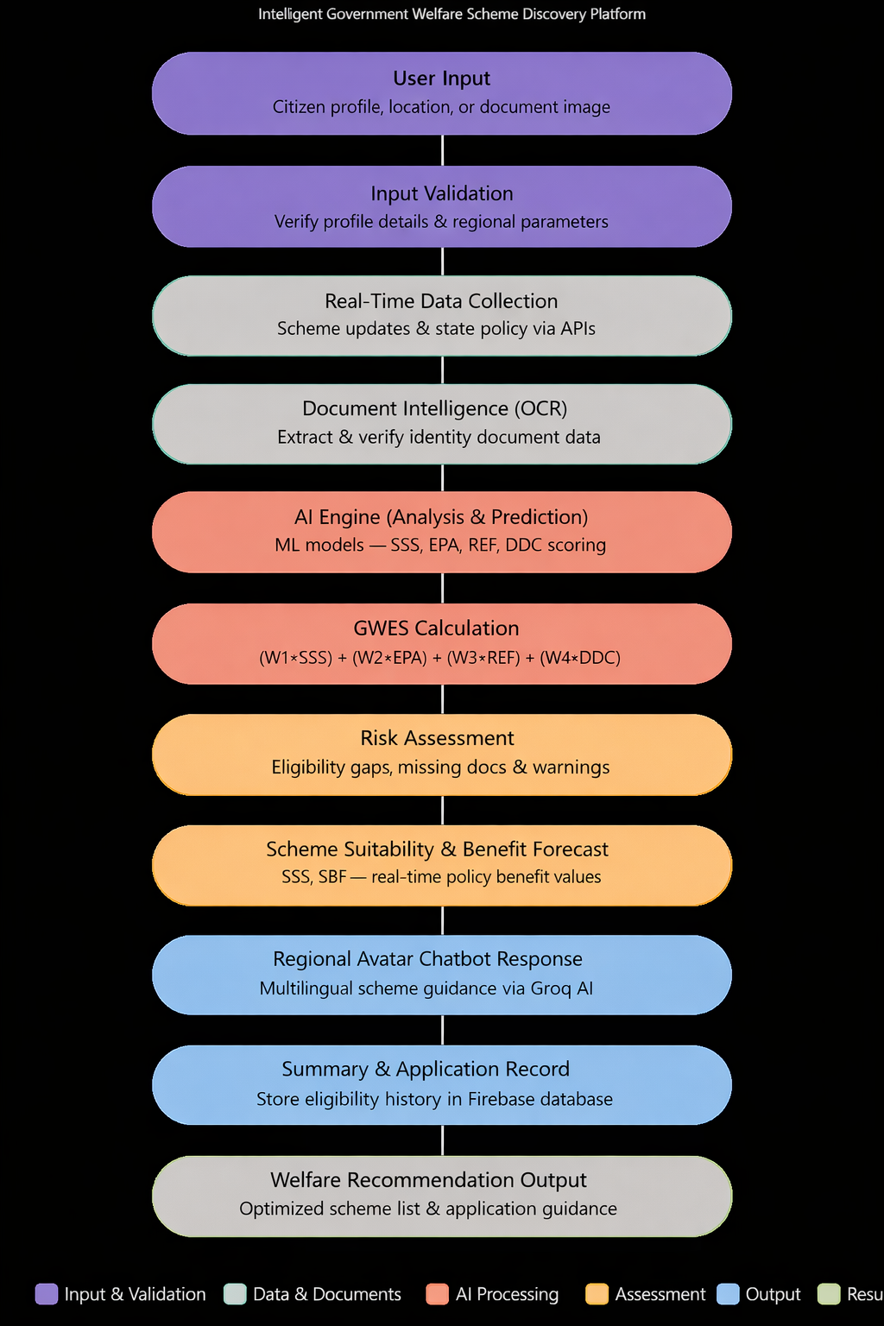
Fig no:5.1 User Flow

5.5.1 LANDING PAGE:

The landing page acts as the initial interaction interface of GovBot India. It introduces the platform as an intelligent government welfare scheme discovery and eligibility assistance system. It provides clear navigation options for citizens to start eligibility checking, access scheme insights, or log into the system.

5.5.2 USER DASHBOARD:

The dashboard functions as the central workspace where citizens access eligibility results, scheme recommendations, and regional avatar chatbot assistance. Users can monitor welfare decisions and manage document inputs efficiently through a simple interface.

5.5.2.1 DATA INPUT MODULE:

This module collects user inputs such as citizen profile details, demographic parameters, geographical location, or identity document images for OCR extraction. The system validates entered data and ensures accurate regional information and required parameters before processing.

5.5.2.2 REAL-TIME DATA COLLECTION MODULE:

GovBot India gathers live government information including scheme updates and state policy data through external APIs. These real-time datasets improve eligibility accuracy and provide updated welfare scheme insights.

5.5.2.3 AI ANALYSIS & PREDICTION MODULE:

The AI engine processes collected data using machine learning models to perform scheme suitability analysis, eligibility prediction, and application planning. The system evaluates demographic, regional, and document factors to generate intelligent welfare recommendations.

5.5.2.4 RISK ASSESSMENT MODULE:

This module analyzes potential risks such as missed entitlements, eligibility gaps, document deficiencies, and application errors. Citizens receive early warnings and preventive suggestions to minimize welfare access risks.

5.5.2.5 DOCUMENT INTELLIGENCE MODULE:

GovBot India uses an OCR-based document extraction model to analyze uploaded identity document images and extract key citizen data. The system identifies document fields and provides verification results along with data accuracy confidence scores.

5.5.3 REGIONAL AVATAR CHATBOT SYSTEM:

The regional avatar chatbot enables citizens to ask welfare-related questions through multilingual text interaction document requirements, application procedures, and government benefit details, improving accessibility for citizens across all regions of India.

5.5.4 SUMMARY & APPLICATION RECORD SECTION:

The Summary Section provides a consolidated view of all eligibility analysis results generated by GovBot India. It displays scheme suitability predictions, eligibility estimation, document verification outcomes, application guidance results, and recommended welfare actions in a single dashboard. Additionally This module helps citizens review past insights, monitor application progress, and make informed decisions for upcoming scheme application cycles.

5.6 GOVBOT INDIA PROCESSING ALGORITHM:

The GovBot India Processing Algorithm manages the complete workflow from data input to intelligent welfare recommendation generation. The system validates user inputs, collects real-time scheme data, performs AI-based eligibility analysis, and generates actionable welfare insights.

The algorithm evaluates key parameters: Scheme Suitability Score (SSS): Measures compatibility between citizen profile and scheme eligibility conditions such as income level, occupation, and location.

Regional Eligibility Factor (REF): Calculates state policy, location, and category-related factors affecting scheme qualification.

Scheme Benefit Forecast (SBF): Provides current and predicted scheme benefit values using government policy data to support welfare planning.

GOVERNMENT WELFARE ELIGIBILITY SCORE (GWES): GovBot India generates recommendations only when the following score is achieved.If GWES exceeds the defined threshold, GovBot India generates optimized scheme recommendations and eligibility guidance.

5.7 IMPLEMENTATION OF THE PROPOSED SYSTEM

GovBot India is implemented using an integrated architecture consisting of three major components:

FRONTEND (REACT UI)

Provides dashboard visualization, citizen input forms, eligibility results, regional avatar chatbot interaction, and application tracking with a responsive design.

BACKEND (NODE.JS + EXPRESS.JS)

Handles API communication, data validation, eligibility requests, Firebase database storage, and user management operations. AI ENGINE (GROQ AI + OCR MODELS) Performs scheme suitability analysis, eligibility prediction, document extraction, and welfare risk assessment using trained

STEP 1: SIGN UP PAGE
When new users visit GovBot India, they can register by providing:
- Full Name
- Email Address
- Password

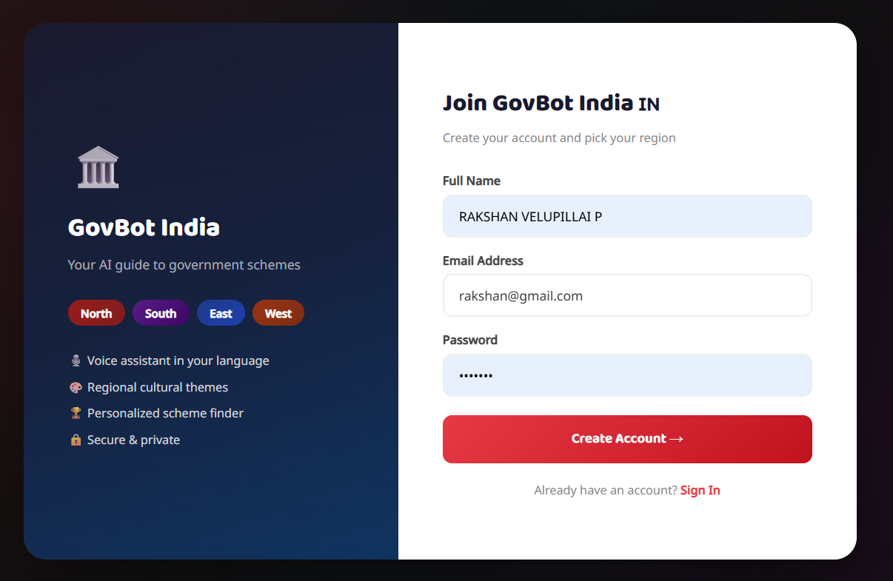
Fig no: 5.2 SIGN UP PAGE – GOVBOT

The Sign Up Page of GovBot India allows citizens to create a new account and select their region. The split-screen interface presents platform highlights on the left while the registration form is displayed on the right, enabling quick and secure onboarding.

STEP 2: LOGIN PAGE

Registered users can securely access GovBot India by entering:
- Email Address
- Password
Features include:
- Secure authentication system
- Personalized regional dashboard access
- Direct Sign Up link for new users

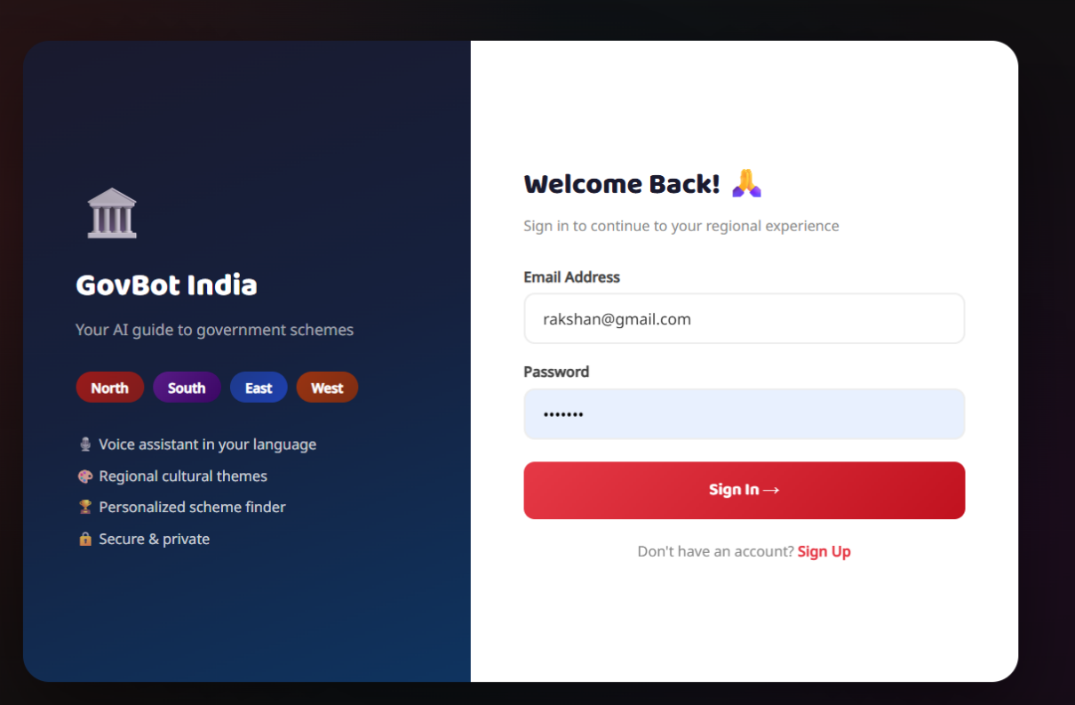

Fig no: 5.3 Login Page

The Login Page enables registered citizens to securely sign into GovBot India using their credentials. After successful authentication, users are redirected to their personalized regional dashboard with scheme recommendations and eligibility .

STEP 3: STATE SELECTION PAGE

After login, users select their home state to personalize the experience. Available states include:
- Tamil Nadu — தமிழ்நாடு
- Kerala — കേരളം
- Karnataka — ಕರ್ನಾಟಕ
- Andhra Pradesh — ఆంధ్రప్రదేశ్
- Telangana — తెలంగాణ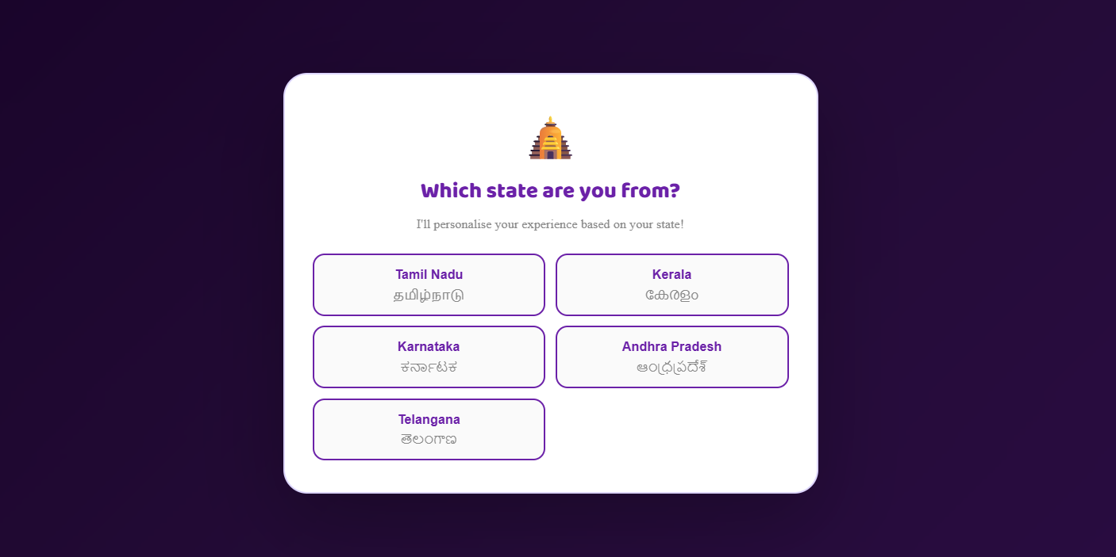
Fig no : 5.4 State Selection Page

The State Selection Page prompts users to choose their home state after login. The system personalizes the interface based on the selected state, adapting the regional avatar, language, and government scheme recommendations to match the citizen's location.

STEP 4: REGIONAL AVATAR CHATBOT PAGE

The Regional Avatar Chatbot acts as the central interaction interface of GovBot India. Features include:
- Region-specific avatar (e.g., Kavitha Menon for South India / Tamil Nadu)
- Multilingual greeting and interaction
- Voice-enabled responses (Audio On/Off toggle)
- Quick Questions for faster scheme discovery
- The chatbot is powered by Groq AI and supports both text and voice input.

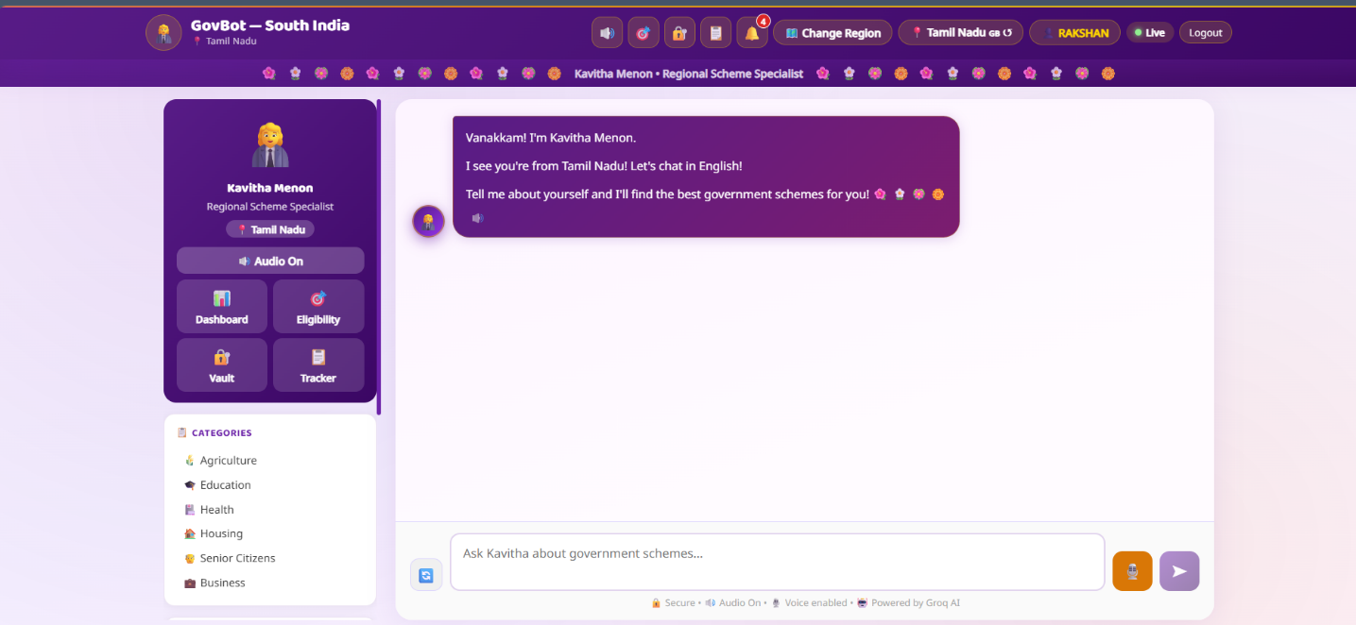

Fig no: 5.5 Regional Avatar Chatbot Page

The Regional Avatar Chatbot Page features Kavitha Menon as the Tamil Nadu Regional Scheme Specialist. The chatbot greets users in their regional language, provides quick question shortcuts, and delivers instant scheme information through voice-enabled multilingual interaction powered by Groq AI.

STEP 5: CHANGE REGION PAGE

Users can switch their region at any time using the Change Region option. Available regions include:
- North India
- South India (Current)
- East India
- West India

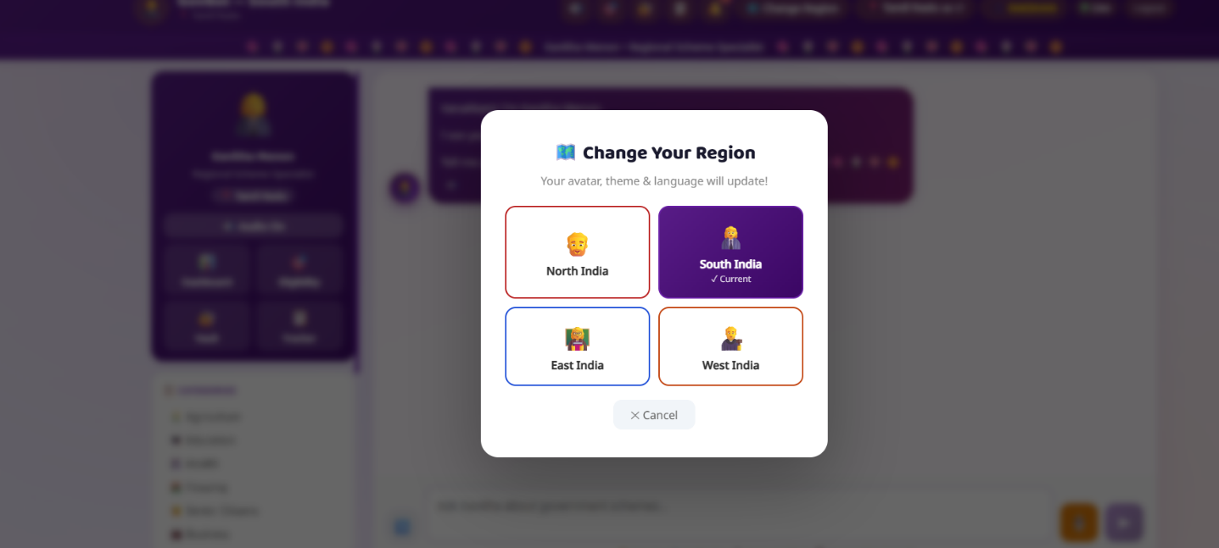
Fig no : 5.6 Change Region Page

The Change Region modal allows citizens to switch between four major regional zones of India. The platform automatically updates the avatar, interface theme, and language upon region selection, ensuring a culturally personalized welfare assistance experience.

STEP 6: CHATBOT RESPONSE PAGE

When users query about specific scheme categories, the chatbot displays:
- Numbered scheme cards with scheme name
- Benefit details (e.g., Rs.6000/yr for PM-KISAN)
- Target beneficiary information (Who qualifies)
- State-specific and central government schemes
Example: Querying "Tell me about Agriculture schemes" displays:
- TN CM Solar Power Scheme
- Anaithu Grama Anna Marumalarchi
- Amma Unavagam
- PM-KISAN
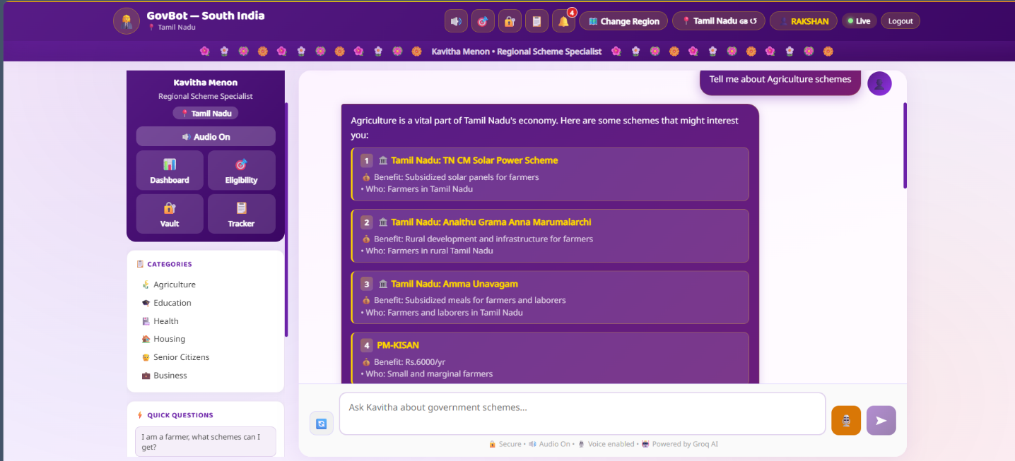

Fig no : 5.7 Chatbot Response Page

The Chatbot Response Page displays Kavitha Menon's AI-generated scheme recommendations based on the user's query. Each result includes the scheme name, benefit value, and eligibility criteria, helping citizens quickly identify suitable.

STEP 7: SCHEME CARDS DISPLAY PAGE

The Scheme Cards page presents welfare schemes in a structured numbered grid layout. Each card displays:
- Scheme Name (e.g., TN Free Laptop Scheme)
- Benefit Details (e.g., Free laptop for Plus-2 students)
- Target Beneficiaries (Who qualifies)
- State label (Tamil Nadu / Central)
- Tap option for detailed scheme information

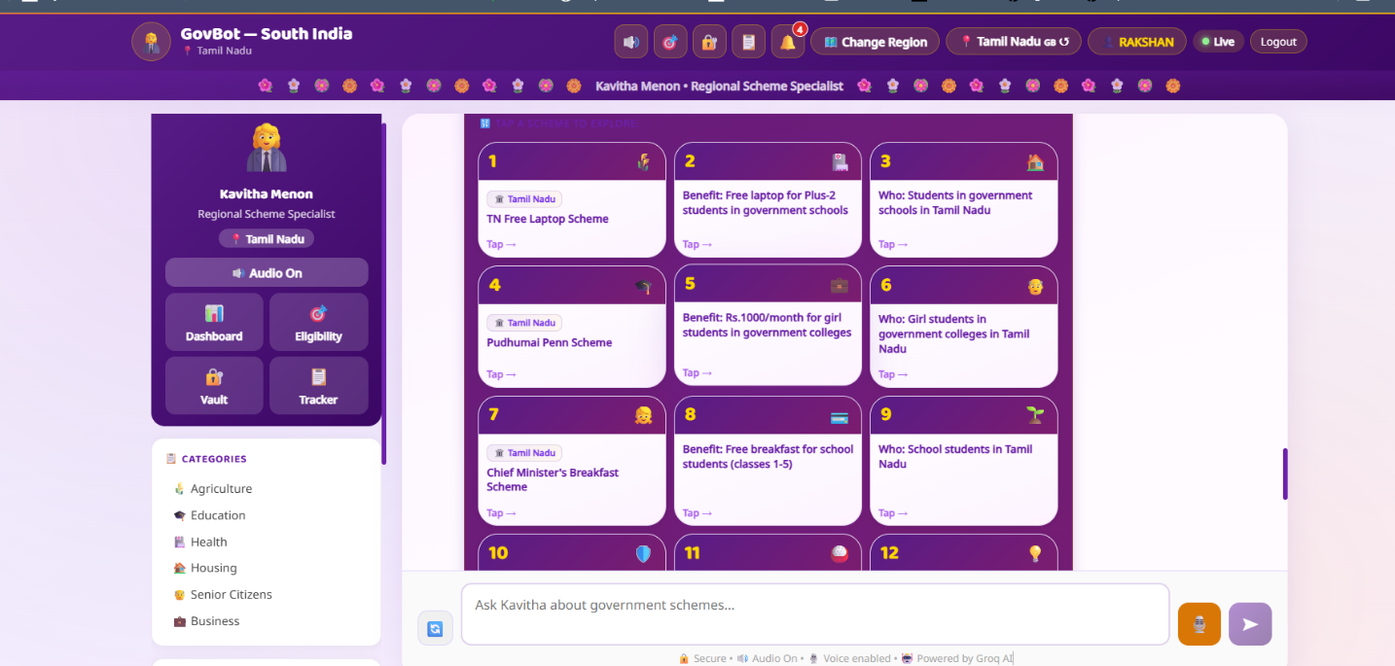

Fig no: 5.8 Scheme Cards Display Page

The Scheme Cards Display Page presents government welfare schemes in an organized numbered card grid format. Citizens can browse schemes by category, view benefit details and eligibility criteria, and tap individual cards to access complete scheme information and application guidance.
STEP 8: ELIGIBLE SCHEMES PAGE

The Eligible Schemes module provides a personalized scheme eligibility summary. Output includes:
- Count of schemes Eligible Now
- Schemes requiring 1 additional document
- Estimated Total Benefit value (₹)
- Two tabs: Eligible and Need Docs

Schemes displayed include:
- PM Kaushal Vikas Yojana — Free skill training + ₹8,000 reward
- NSP Scholarship : ₹3,500 to ₹10,000/year for studies
- PM Vidyalakshmi : Education loans at subsidized rates
- PM Awas Yojana (Urban) : Interest subsidy up to ₹2.67 lakh
- PM Jeevan Jyoti Bima : ₹2 lakh life insurance at ₹436/year

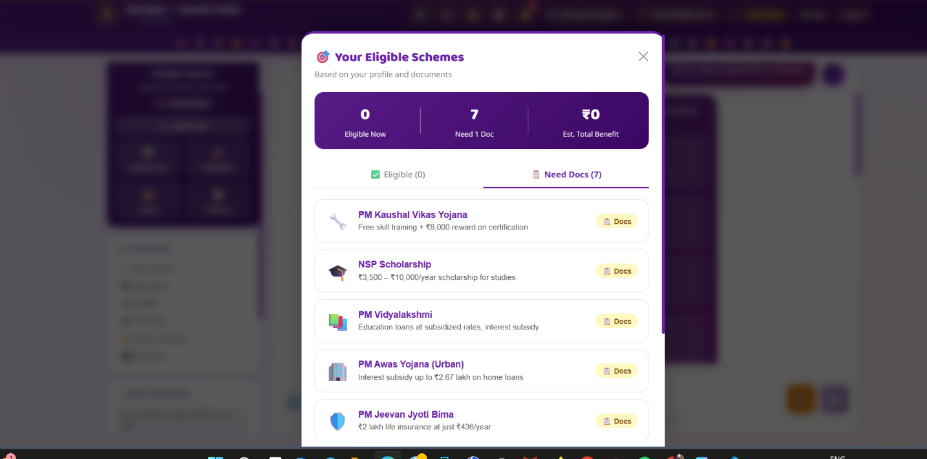

Fig no: 5.9 Eligible Schemes Page

The Eligible Schemes Page provides a consolidated view of all government schemes the citizen qualifies for based on their profile and uploaded documents. It separates immediately eligible schemes from those requiring additional documentation, along with estimated total benefit value to support informed welfare decisions.

STEP 9: NOTIFICATIONS PANEL
The Notifications Panel delivers real-time alerts to keep citizens informed. Alert types include:
- Critical document warnings (e.g., missing Aadhaar)
- Profile completion reminders with percentage indicator
- Unapplied eligible scheme alerts (e.g., Ayushman Bharat, Janani Suraksha Yojana, NSP Scholarship)
- Push notification enable option

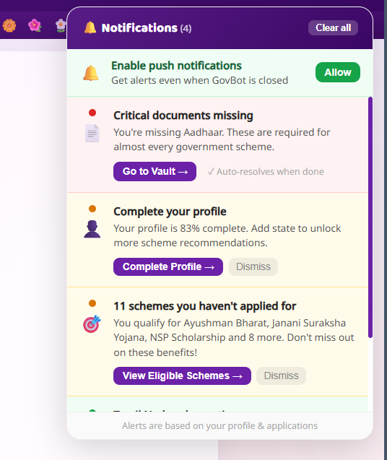

Fig no : 5.10 Notifications Panel

The Notifications Panel provides real-time actionable alerts to citizens regarding missing documents, incomplete profile details, and unapplied eligible schemes. It ensures citizens never miss welfare entitlements by delivering timely warnings and direct navigation to relevant platform modules.

STEP 10: DOCUMENT VAULT PAGE

The Document Vault provides secure encrypted storage for citizen identity documents. Features include:
- Vault Completeness indicator (e.g., 80%)
- Encrypted document storage with owner name display
- Stored documents: Income Certificate, Bank Passbook, PAN Card, Birth Certificate
- Empty slots for: Aadhaar Card, Land Record/Patta, Caste Certificate, Ration Card
- Add and Delete document options

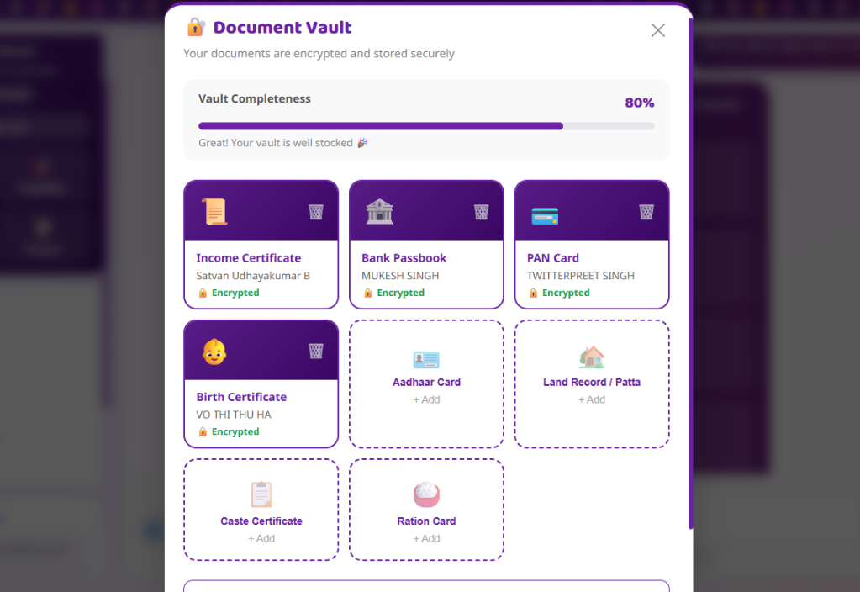
Fig no : 5.11 Document Vault Page

The Document Vault Page offers citizens a secure, encrypted space to store and manage their identity documents required for government scheme applications. The vault completeness indicator guides users to upload missing documents, improving eligibility accuracy and application readiness.

STEP 11: APPLICATION TRACKER PAGE

The Application Tracker enables citizens to monitor their government scheme applications. Dashboard displays:
- Active applications count
- Approved applications count
- Rejected applications count
- Total applications count

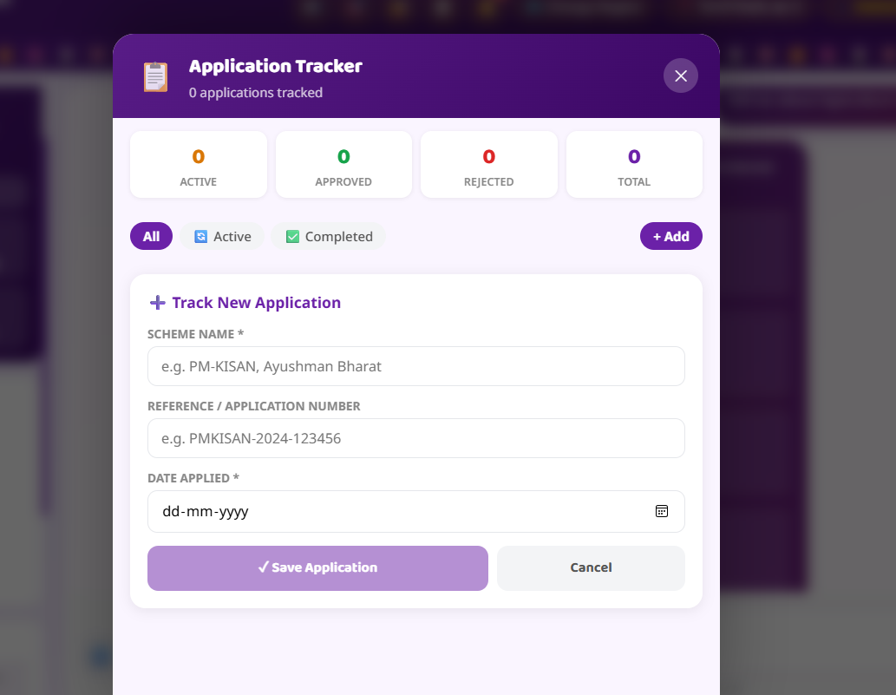

Fig no: 5.12 Application Tracker Page

The Application Tracker Page allows citizens to record and monitor all their government scheme applications in one place. It provides a structured tracking interface with status categories and a simple form to add new application records for efficient welfare management.

STEP 12: MY DASHBOARD — OVERVIEW PAGE

After login, the Dashboard Overview displays the citizen's complete profile summary. Information shown includes:
- Profile Completeness indicator (100%)
- Verified fields: Name, Age, Occupation, Income, Family Size, Gender.
- My Info section with all citizen details in card layout
- Edit option for profile updates
- Tabs: Overview, Schemes, Vault, Activity

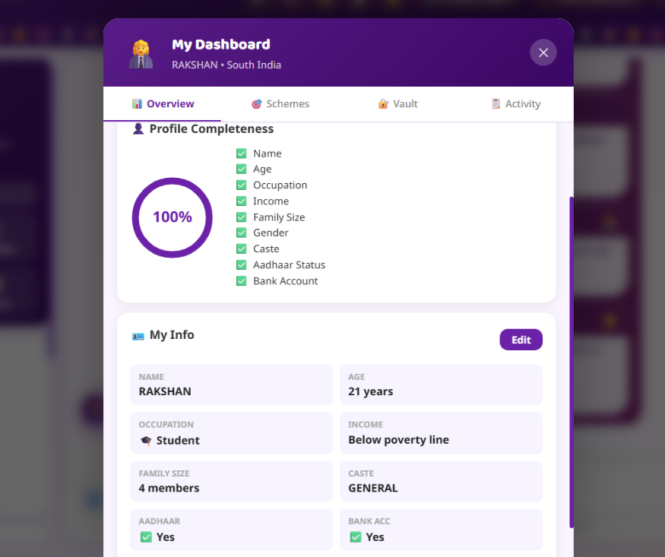

Fig no : 5.13 My Dashboard — Overview Page

The My Dashboard Overview Page acts as the central profile management interface of GovBot India. It displays the citizen's profile completeness status, verified personal details, and quick access to scheme recommendations, document vault, and activity history through an organized tab-based layout.

STEP 13: MY PROFILE PAGE

The My Profile modal presents the user's scheme-matching details in a structured format. Details displayed include:
- Name, Age, Occupation, Income
- Family Size, Caste, Aadhaar, Bank Account status
- Two tabs: Profile and Appearance
- Edit Profile button for updating information
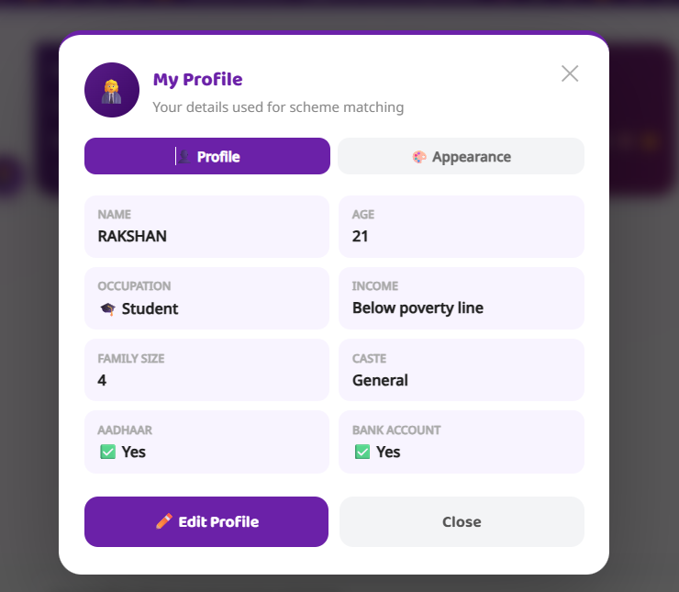

Fig no : 5.14 My Profile Page

The My Profile Page displays all citizen details used for government scheme matching in a clean two-column card layout. Users can review their registered information, switch to the Appearance tab for theme customization, and edit their profile to ensure accurate eligibility recommendations.

STEP 14: PROFILE APPEARANCE SETTINGS PAGE

The Appearance tab allows users to customize the GovBot India visual interface. Four theme options available:
- Festive Indian — Warm gradients, gold shimmer (Default)
- Glassmorphism — Frosted glass, blur effects
- Neon Glow — Electric accents, dark background
- Premium Fintech — Clean, minimal, sharp
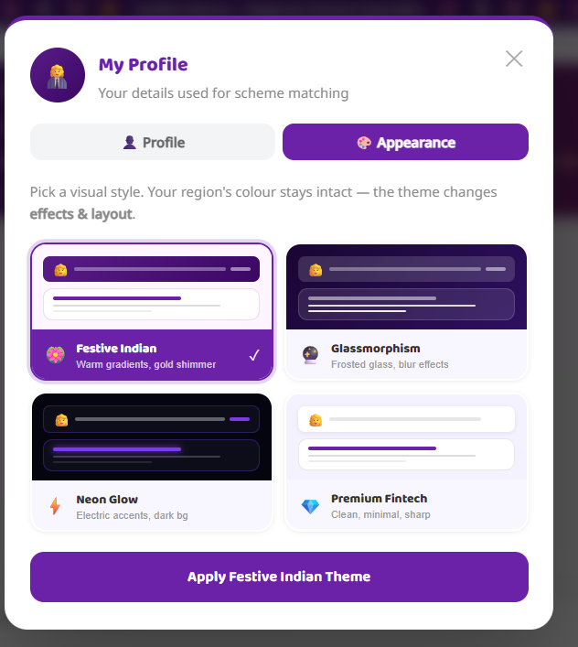

Fig no : 5.15 Profile Appearance Settings Page

The Profile Appearance Settings Page enables citizens to personalize the GovBot India interface by selecting from four distinct visual themes. The regional color scheme stays consistent across all themes, ensuring cultural identity is preserved while the layout and visual effects adapt to the user's preference.

STEP 15: EDIT PROFILE — OCCUPATION SELECTION (STEP 2 OF 4)

The Edit Profile wizard collects citizen details across four guided steps.
- Farmer
- Student
- Business Owner
- Homemaker / Woman
- Govt Employee
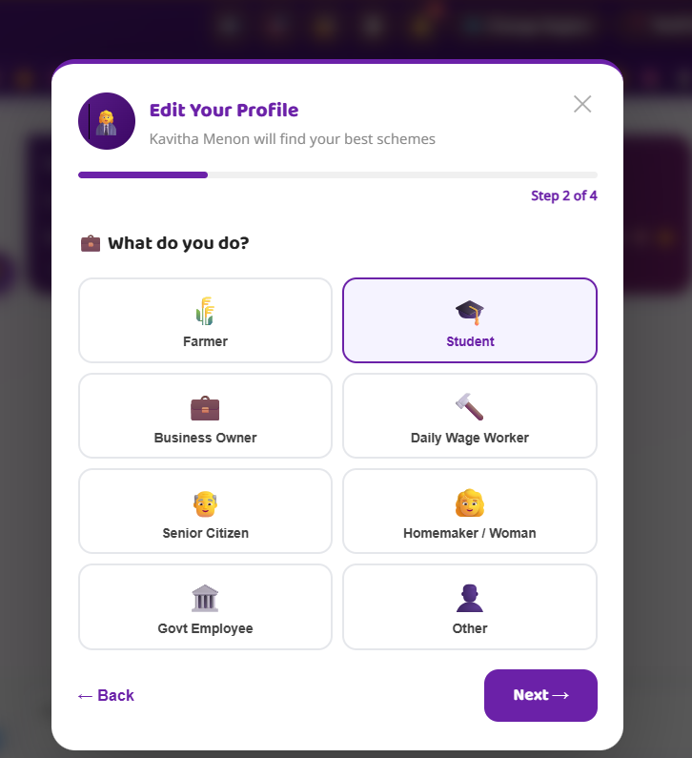

Fig no: 5.16 Occupation Selection Page

The Occupation Selection step of the Edit Profile wizard allows citizens to identify their primary occupation from eight category options. The selected occupation is used by the AI engine to filter and match the most relevant government welfare schemes for the citizen's profile.

STEP 16: EDIT PROFILE — INCOME & CASTE (STEP 3 OF 4)

Users can manage:
- Personal details
- Farm information
- Language preferences

The Profile Management page also displays the current crop status, allowing users to quickly view ongoing cultivation details, progress updates, and related farming insights in one place for better monitoring and decision-making.

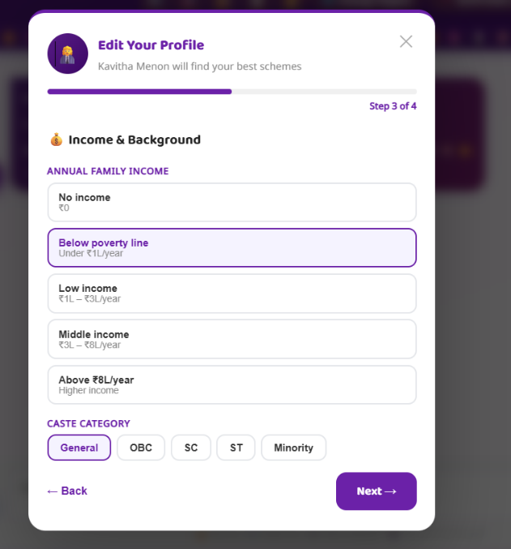

Fig no: 5.17 Profile Management Page

The Profile Management section allows users to customize their account and maintain personalized farming records.
STEP 16: EDIT PROFILE — INCOME & CASTE (STEP 3 OF 4)

Step 3 of the Edit Profile wizard collects financial and social category information. Annual Family Income options include:
- No Income : ₹0
- Below Poverty Line : Under ₹1L/year
- Low Income : ₹1L–₹3L/year
- Middle Income : ₹3L–₹8L/year
- Above ₹8L/year : Higher income

5.7.1 TECHNOLOGIES, PACKAGES, AND RUNTIME ENVIRONMENT USED IN GOVBOT INDIA

GovBot India follows a three-layer architecture consisting of a React Frontend, Node.js Backend API, and AI Engine powered by Groq AI and OCR models. The system integrates machine learning models, real-time government scheme data processing, and a regional avatar chatbot to provide intelligent welfare eligibility.
1. Frontend (React + Vite Client)

The frontend provides an interactive dashboard where citizens can check welfare eligibility, upload identity documents for OCR extraction, interact with the regional avatar chatbot, and view scheme recommendations and eligibility analysis.
- React – User interface development
- Vite – Fast development and build tool
- Axios – API communication
- CSS / Tailwind CSS – Responsive styling
- Geolocation API – Current location detection and data detection.
- Image Upload API – Identity document image input for OCR
- Local Storage API – Store user preferences and language settings.

2. Backend Layer (Node.js + Express Server)
The backend manages API routing, authentication, review systems, chatbot requests, and communication between frontend and AI models.
3. AI Engine (Groq AI + OCR Model)
This layer performs scheme suitability analysis, eligibility prediction, welfare risk assessment, and identity document data extraction and real-time citizen inputs.
Packages Used
- Flask – backend AI API Server
- Flask-CORS – allow cross-domain requests
- Groq SDK – AI-powered eligibility prediction and chatbot response ..
4. AI Model & API Setup
This section describes the AI model configuration and API setup used in GovBot India for welfare eligibility prediction and scheme recommendation.
Install Required Python Packages
Install Flask
pip install flask
Install Requests
pip install requests
Install CORS
pip install flask-cors

FINAL OUTCOME

GovBot India enables citizens to access government welfare schemes through an intelligent digital platform. Users can:

Predict suitable welfare schemes based on income, category,

Estimate eligibility probality using the GWES.

Detect and extract data from identity documents using OCR.

Receive application planning guidance with document checklists.

View real-time government scheme benefit forecasts.

CHAPTER–6

MODULE DESCRIPTION

6.1 AUTHENTICATION MODULE

6.1.1 USER LOGIN:

Allows citizens to securely log in using email and password authentication. After successful login, users are redirected to the personalized welfare dashboard where they can access eligibility predictions, scheme recommendations, document vault, avatar chatbot assistance, and application analytics.

6.1.2 ADMIN LOGIN:

Provides administrative access to manage platform activities such as monitoring citizen registrations, reviewing feedback, managing government scheme datasets, updating AI eligibility models, and supervising system performance and Firebase database records.

6.2 CITIZEN PROFILE & DATA INPUT MODULE

This module collects citizen profile details including demographic parameters, geographical location, income level, occupation, and category information required for welfare eligibility analysis. Identity document images can be uploaded for OCR-based data extraction. The system validates all entered data and ensures accurate regional and eligibility parameters before processing.

6.3 SCHEME ELIGIBILITY ANALYSIS MODULE

Allows citizens to check their welfare scheme eligibility based on submitted profile data.

Features Include:

Submit citizen profile for eligibility analysis

Display scheme suitability scores (SSS) and eligibility

Provide daily scheme recommendation updates

Track eligibility status across multiple schemes
- Generate Government Welfare Eligibility Score (GWES)

This module supports continuous welfare monitoring throughout the citizen's scheme application lifecycle.

6.4 DOCUMENT INTELLIGENCE MODULE

Uses OCR-based AI models to extract and verify citizen identity document data from uploaded images.

Functions:

Document image upload and preprocessing

Data field extraction using trained OCR model

Display extracted fields with Document Detection Confidence (DDC)

Early warning system for missing or invalid documents

6.5 SCHEME INSIGHTS & ANALYTICS MODULE

Provides real-time government welfare scheme information and benefit analytics.

Features:

Current welfare scheme benefit value updates

Monthly eligibility trend visualization using bar graphs

Scheme Benefit Forecast (SBF) dashboards using charts

Helps citizens decide optimal application submission timing.

6.6 REGIONAL AVATAR CHATBOT MODULE

An intelligent multilingual avatar chatbot that provides instant welfare guidance and scheme eligibility assistance. The chatbot improves citizen decision-making by offering real-time AI responses in regional Indian languages and English.

6.7 REVIEW & FEEDBACK MODULE

Allows citizens to submit reviews and feedback about system performance and welfare scheme assistance outcomes.

Functions:

User rating and comments

Experience sharing among citizens

Helps improve system accuracy and usability through feedback analysis

6.8 PROFILE MANAGEMENT MODULE

The Profile Management Module enables citizens to manage their personal account settings and application preferences efficiently. Users can update profile information, select preferred language options such as Tamil, Hindi, or English, and view their eligibility history and saved scheme data..

6.9 SECURITY MODULE

The Security Module ensures safe and reliable system operation by implementing secure authentication and protected data communication. JWT-based authentication is used to verify citizen access, while encrypted HTTPS communication safeguards data transmission. The module also protects sensitive citizen information stored in the Firebase database and restricts unauthorized API access.

6.10 USER INTERFACE (UI) MODULE

Provides a responsive and farmer-friendly interface with:

Clean tricolor-themed dashboard design

Mobile and desktop compatibility

Interactive eligibility charts and welfare analytics

6.11 MODULE WORKFLOW DIAGRAM

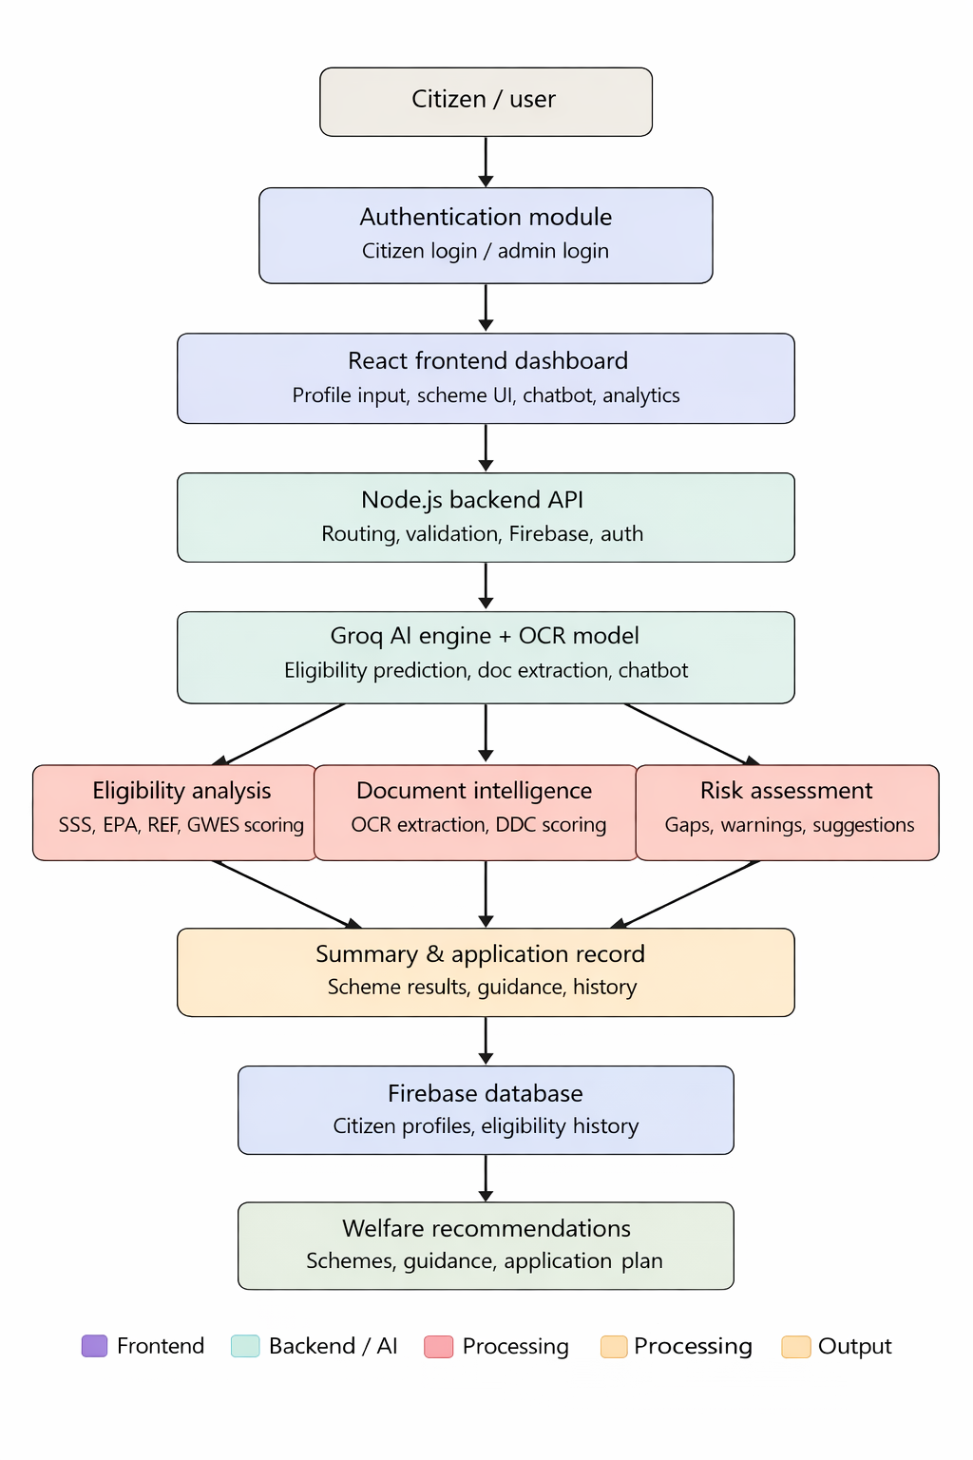
Fig no: 6.1 Module Workflow

CHAPTER–7

RESULT AND DISCUSSION
7.1 RESULT

GovBot India – Intelligent Government Welfare Scheme Discovery and Eligibility Assistance Platform successfully demonstrates how artificial intelligence can support citizens in accessing government welfare schemes through data-driven eligibility analysis. The system integrates scheme suitability prediction, real-time government data collection, document intelligence, risk assessment, and regional avatar chatbot interaction within a single web-based platform.The platform allows citizens to submit their profile details and receive a Government Welfare Eligibility Score (GWES) based on key parameters including Scheme Suitability Score (SSS), Eligibility Prediction Accuracy (EPA), Regional Eligibility Factor (REF), and Document Detection Confidence (DDC). After eligibility analysis, the system automatically generates optimized scheme recommendations, application planning guidance, and document checklists, helping citizens navigate the welfare application process efficiently.Using machine learning models and OCR-based document extraction, GovBot India accurately predicts scheme eligibility, identifies document deficiencies, and evaluates welfare access risks based on demographic, regional, and policy data. The integration of real-time scheme benefit forecasts along with eligibility analytics enables citizens to understand their entitlements and make informed decisions about scheme applications.Additionally, the system includes a regional avatar chatbot that provides instant multilingual welfare guidance and a review system that allows users to share feedback and experiences, improving platform reliability and citizen engagement.

7.2 DISCUSSION

FEATURE | Proposed (AI-Driven) System
Scheme eligibility | AI-based eligibility analysis using demographic and location data
Document intelligence | OCR-based identity document extraction with confidence.
Risk assessment | Identifies eligibility gaps, document deficiencies, and application errors
Scheme insights & analytics | Real-time scheme benefit forecasts with eligibility trend visualization
Welfare eligibility score | GWES computed from SSS, EPA, REF, and DDC parameters
Application planning | Document checklists, portal links, and submission timeline guidance
Regional avatar chatbot | Multilingual AI assistant for welfare queries and scheme guidance
Data Visualization | Interactive charts and analytics dashboard.
Review System | User feedback improves system usability.
Scalability | Cloud-ready architecture supporting multiple users

Table no: 7.1 Discussion Table

CHAPTER–8

CONCLUSION & FUTURE WORK

8.1 CONCLUSION

The GovBot India platform successfully presents an intelligent government welfare assistance system that combines artificial intelligence, machine learning, OCR technology, and modern web technologies to support citizens in discovering and accessing welfare schemes. By integrating scheme eligibility prediction, document intelligence, risk assessment, real-time scheme data collection, and application planning, the system provides a comprehensive digital welfare guidance solution.The inclusion of the regional avatar chatbot enables multilingual citizen interaction, while AI-driven analytics help citizens understand their eligibility and entitlements. The review system and summary record module further enhance usability by providing real-time assistance, eligibility history tracking, and user-driven platform improvements.Overall, GovBot India demonstrates how technology can simplify complex government welfare processes, reduce eligibility gaps, and promote smarter and more inclusive access to government schemes for citizens across India.

8.2 FUTURE WORK

Future enhancements of GovBot India aim to expand functionality and provide multi-level welfare support. Planned improvements include:

- Multi-state scheme coverage: Region-specific eligibility recommendations based on state government policies and local welfare programs across all Indian states and union territories.

- Calendar Synchronization: Seamless connection with Google Calendar and Microsoft Outlook for scheme application deadline reminders and submission event management.

- IoT and DigiLocker integration: Connecting with DigiLocker and government digital identity systems for automatic document retrieval and real-time verification.

- Enhanced Analytics Dashboard: More visual insights for eligibility trend tracking, benefit forecasting, and scheme application success rate monitoring.

- Multi-Language Support Enhancement: Currently, GovBot India supports regional Indian languages including Tamil and English, enabling citizens to interact with the system in their preferred language.

- Mobile Application: Dedicated mobile app with offline access features.

APPENDICES

APPENDIX

Frontend:

import { useState, useRef, useEffect } from "react";
import AuthPage from "./AuthPage.jsx";
import SchemeMenu from "./SchemeMenu.jsx";
import ProfileSetup from "./ProfileSetup.jsx";
import EligibilityReport from "./EligibilityReport.jsx";
import ApplyFlow from "./ApplyFlow.jsx";
import Dashboard from "./Dashboard.jsx";
import StatusTimeline from "./StatusTimeline.jsx";
import NotificationCenter from "./NotificationCenter.jsx";
import { getThemeStyles, DEFAULT_THEME } from "./utils/themeEngine.js";
import RichMessage from "./RichMessage.jsx";
import { getEligibilitySummary } from "./utils/eligibilityChecker.js";
import DocumentVault from "./DocumentVault.jsx";
import { setSessionKey, clearSessionKey } from "./utils/keyManager.js";
import { onAuthStateChanged } from "firebase/auth";
import { startSessionTimer, stopSessionTimer } from "./utils/sessionTimeout.js";
import GreetingPage from "./GreetingPage.jsx";
import StateSelector from "./StateSelector.jsx";
import { REGIONS, SCHEMES_CONTEXT, ALL_REGION_STATES } from "./regions.js";

const suggestedQuestions = [

const [profileComplete, setProfileComplete] = useState(false);
const [showProfileSetup, setShowProfileSetup] = useState(false);
const [loggingOut, setLoggingOut] = useState(false);
const [showDashboard, setShowDashboard] = useState(false);
const [showTracker, setShowTracker] = useState(false);
const [notifUnread, setNotifUnread] = useState(0);
const [activeTheme, setActiveTheme] = useState(DEFAULT_THEME);
const [selectedState, setSelectedState] = useState(null);
const [useNativeLang, setUseNativeLang] = useState(false);
const messagesEndRef = useRef(null);
const recognitionRef = useRef(null);
const abortControllerRef = useRef(null);
const sessionIdRef = useRef(0);
const lastCategoryRef = useRef(""); // incremented on refresh to block stale audio

const region = user ? REGIONS[user.region] : null;
const themeStyles = (region && typeof getThemeStyles === "function") ? getThemeStyles(activeTheme, region.colors) : {};
const isDarkTheme = activeTheme === "glass" || activeTheme === "neon";

useEffect(() => {
messagesEndRef.current?.scrollIntoView({ behavior: "smooth" });
}, [messages]);

// Restore session on page refresh
useEffect(() => {
import("./firebase.js").then(({ auth, db, doc, getDoc }) => {
onAuthStateChanged(auth, async (firebaseUser) => {
if (!firebaseUser) {
setPhase("auth"); // No user logged in
return;
}
if (firebaseUser && !user) {
// Restore user session
try {
const snap = await getDoc(doc(db, "users", firebaseUser.uid));
const data = snap.exists() ? snap.data() : {};
const restored = {
uid: firebaseUser.uid,
name: firebaseUser.displayName || data.name || "User",
email: firebaseUser.email,
region: data.region || "south",

Backend (server.js) :

import express from "express";
import cors from "cors";
import mongoose from "mongoose";
import dotenv from "dotenv";

import authRoutes from "./routes/auth.js";
import schemeRoutes from "./routes/scheme.js";
import aiRoutes from "./routes/ai.js";
import eligibilityRoutes from "./routes/eligibility.js";
import notificationRoutes from "./routes/notifications.js";
import documentRoutes from "./routes/document.js";
import profileRoutes from "./routes/profile.js";
import summaryRoutes from "./routes/summary.js";
import reviewsRoutes from "./routes/reviews.js";
import chatbotRoutes from "./routes/chatbot.js";

dotenv.config();
const app = express();

app.use(
cors({
origin: ["http://localhost:5173", "http://localhost:8080", "http://127.0.0.1:8080"],
credentials: true,
}),
);

// Increase JSON payload limit (identity document images, OCR requests)
app.use(express.json({ limit: "12mb" }));
app.use(express.urlencoded({ extended: true, limit: "12mb" }));

// Fast-fail API calls when DB is unavailable (prevents long timeouts + noisy logs)
app.use((req, res, next) => {
if (!req.path.startsWith("/api")) return next();
if (req.path === "/api/health") return next();

REFERENCES

REFERENCED LITERATURES

[1] Zhang et al. (2016).This study focuses on data-driven public welfare systems using citizen data and GIS. It improves scheme accessibility, reduces manual errors, and enhances transparency in service delivery.

[2] Wolfert et al. (2017).The research explains AI-based digital inclusion using real-time data and cloud platforms. It highlights improved accessibility and challenges like language barriers and digital literacy..

[3] Kamilaris and Prenafeta-Boldú (2018).This paper reviews machine learning techniques like decision trees and neural networks. It shows how ML improves prediction accuracy in public service systems.

[4] Mohanty et al. (2018).The study demonstrates deep learning models (CNNs) for document and image processing. It improves accuracy in automated data extraction and verification.

[5] Jeong et al. (2019).This research highlights the role of regional and demographic factors in welfare prediction. It supports dynamic and location-based eligibility models.

[6] Rao and Srivastava (2019).The paper discusses decision support systems for public services. It emphasizes analytics and dashboards for better citizen understanding and decision-making.

[7] Sharma et al. (2020).This study proposes AI-based systems to recommend schemes using citizen data. It improves accuracy and personalization compared to manual selection.

[8] Li et al. (2020).The research focuses on predicting welfare risks using demographic analytics. It helps identify missed benefits and eligibility gaps.

[9] Kumar and Patel (2021).This study highlights web-based government platforms for accessibility and scalability. It enables citizens to access services through browsers easily.

[10] Singh et al. (2021).The paper emphasizes visualization techniques like charts and dashboards. It improves citizen understanding of schemes and eligibility.

[11] Fernandez et al. (2022).This research introduces AI-driven optimization for welfare systems. It reduces errors, improves efficiency, and enhances service quality.

[12] Tjoa and Guan (2022).The study explains Explainable AI (XAI) for transparent decision-making. It builds trust by providing clear reasoning behind AI outputs.

[13] Rahman et al. (2023).This paper discusses integrated welfare platforms combining multiple services. It improves user experience and system efficiency.

[14] Chen et al. (2024).The research presents AI-based decision support systems for welfare services. It improves application accuracy and reduces complexity.

[15] Patel et al. (2024).This study focuses on early eligibility prediction using AI and demographic data. It helps reduce missed opportunities and improves access.

[16] Garcia and Lopez (2025).The paper highlights web-based AI platforms for inclusive welfare access. It ensures easy usage without requiring installations.

[17] Kumar and Verma (2025).This research explains cloud-based AI systems for welfare analytics. It supports real-time monitoring and personalized recommendations.

